Name: MOUNVI PODAPATI

Reg. No: 19BCE0396

Slot: L25 + l26

Faculty: Prof. Lydia Jane

Lab Assignment – 27/08/2021

landing.html

<html>

<head>

    <title>Umbrella House</title>

    <link rel="stylesheet" href="style.css">

</head>

<body style="overflow-x: hidden;">

    <header style="text-align:center;color:white">

        <h2>Welcome to the Umbrella House</h2>

        <img src="./img/gala1.jpg" />

    </header>

    <nav style="float:right;width:100%">

        <ul>

            <li><a href="#products">Products</a></li>

            <li><a href="#galas">Galas</a></li>

            <li><a href="mailto:mounvip1525@gmail.com?subject=Umbrella%20House">Contact</a></li>

        </ul>

    </nav>

    <main style="text-align: center;">

        <figure>

            <img src="/img/gala1.jpg" height="500" width="500" style="margin-top: 3%;">

            <figcaption>The umbrella house is a 2021 established community where we sell beautiful umbrellas to our

                customers and let you know about the most special umbrella gala's around the world!</figcaption>

        </figure>

        <div style="display:inline-flex;padding:3%;width:90%">

            <section class="gala-main" id="galas" style="width:70%;border:2px solid purple">

                <h2>Umbrella Galas</h2>

                <div>

                    <article>

                        <img src="/img/gala2.jpg" height="300" width="600" />

                        <h3>West Side Gala</h3>

                        <a href="attend.html">Attend</a>

                    </article>

                    <article>

                        <img src="/img/gala1.jpg" height="300" width="600" />

                        <h3>East Side Gala</h3>

                        <a href="attend.html">Attend</a>

                    </article>

                </div>

            </section>

            <aside style="width:25%;border:2px solid purple;margin:0 2%;clear:both">

                <article>

                    <header>West Side Gala</header>

                    <details>We offer exquisite Gala Coupons once in a blue moon and you will not believe but its the

                        most unbelievable experience you will ever experience</details>

                </article>

                <article>

                    <header>East Side Gala</header>

                    <details>We offer exquisite Gala Coupons once in a blue moon and you will not believe but its the

                        most unbelievable experience you will ever experience</details>

                </article>

                <article>

                    <header>West Side Gala</header>

                    <details>We offer exquisite Gala Coupons once in a blue moon and you will not believe but its the

                        most unbelievable experience you will ever experience</details>

                </article>

                <article>

                    <header>East Side Gala</header>

                    <details>We offer exquisite Gala Coupons once in a blue moon and you will not believe but its the

                        most unbelievable experience you will ever experience</details>

                </article>

                <article>

                    <header>West Side Gala</header>

                    <details>We offer exquisite Gala Coupons once in a blue moon and you will not believe but its the

                        most unbelievable experience you will ever experience</details>

                </article>

                <article>

                    <header>East Side Gala</header>

                    <details>We offer exquisite Gala Coupons once in a blue moon and you will not believe but its the

                        most unbelievable experience you will ever experience</details>

                </article>

                <article class="sm-article">

                    We are an enthusiastic team delivering a great user experience to both our internal and external, We

                    are an enthusiastic team delivering a great user experience to both our internal and external, We

                    are an enthusiastic team delivering a great user experience to both our internal and external, We

                    are an enthusiastic team delivering a great user experience to both our internal and external, We

                    are an enthusiastic team delivering a great user experience to both our internal and external, We

                    are an enthusiastic team delivering a great user experience to both our internal and external

                    We are an enthusiastic team delivering a great user experience to both our internal and external, We

                    are an enthusiastic team delivering a great user experience to both our internal and external, We

                    are an enthusiastic team delivering a great user experience to both our internal and external, We

                    are an enthusiastic team delivering a great user experience to both our internal and external, We

                    are an enthusiastic team delivering a great user experience to both our internal and external, We

                    are an enthusiastic team delivering a great user experience to both our internal and external

                </article>

            </aside>

        </div>

        <section class="product-main" id="products">

            <h2>Our Products</h2>

            <div>

                <article>

                    <img src="img/blue.jpg" alt="Blue Umbrella" height="250" width="250" />

                    <h3><mark>Blue Bae</mark></h3>

                    <a href="blue.html" class="a-tag">Details</a>

                </article>

                <article>

                    <img src="/img/pink.jpg" alt="Pink Umbrella" height="250" width="250" />

                    <h3><mark>Pink Beauty</mark></h3>

                    <a href="pink.html" class="a-tag">Details</a>

                </article>

                <article>

                    <img src="img/yellow.jpg" alt="Yellow Umbrella" height="250" width="250" />

                    <h3><mark>Yellow Dwell</mark></h3>

                    <a href="yellow.html" class="a-tag">Details</a>

                </article>

                <article>

                    <img src="img/traditional.jpg" alt="Traditional Umbrella" height="250" width="250" />

                    <h3><mark>Authentic Us</mark></h3>

                    <a href="traditional.html" class="a-tag">Details</a>

                </article>

            </div>

        </section>

    </main>

    <footer style="padding:1%;color:white">

        <p style="display:inline">Made by Mounvi</p>

        <p style="float:right;margin:0">Lab Assignment - 27/08/2021</p>

    </footer>

</body>

</html>

style.css

body{

    padding:0;

    margin:0;

}

header{

    background: rgba(10, 44, 83, 0.938);

    padding:1%;

}

header img{

    height:80px;

    width:80px;

    border-radius: 50%;

    position:absolute;

    top:1%;

    left:1%;

}

nav{

    background:rgba(25, 59, 97, 0.938);

    align-items: center;

    height:40px;

}

ul{

    list-style-type: none;

    float: right;

    display: block;

    width: 500px;

    text-align: end;

}

li{

    display:inline

}

li a{

    margin:1%;

}

a{

    text-decoration: none;

    color:white;

}

footer{

    background:rgba(25, 59, 97, 0.938);

}

figure img{

    object-fit: contain;

    height:20rem;

    margin:2%;

}

.product-main>div{

    display:flex;

    justify-content: center;

    width:100vw;

}

.product-main div article{

    margin:0.5%;

    background:rgba(128, 128, 128, 0.11);

    padding:2%;

    border-radius:5px;

}

.product-main div img{

    object-fit: cover;

}

.a-tag{

    color:purple;

}

article header{

    color:white;

    font-family: 'Segoe UI';

    font-size: large;

}

.sm-article{

    background:rgba(128, 128, 128, 0.11);

    padding:2%;

    text-align: justify;

    margin:2%;

}

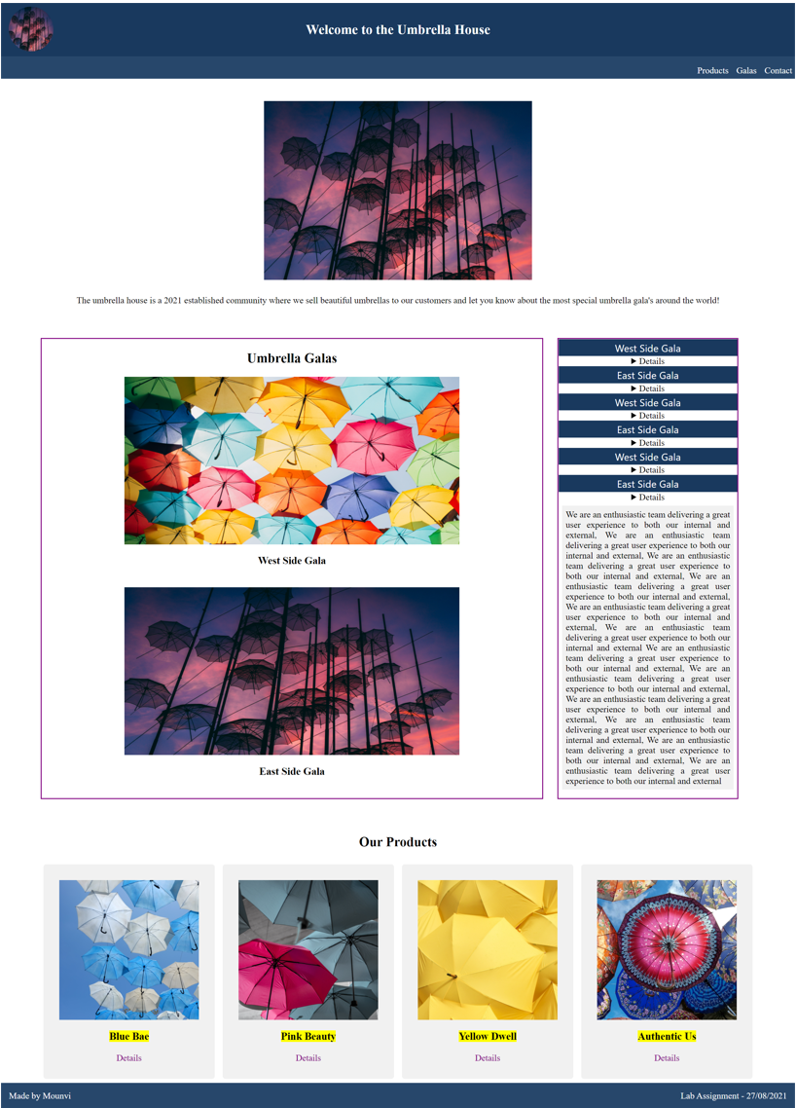Full Screen Img:- (taken using Go Full Page extension)

